COURSE OVERVIEW PE0909(PE8)
Oil & Gas Pipeline Troubleshooting & Operation
Problem Solving

Course Title

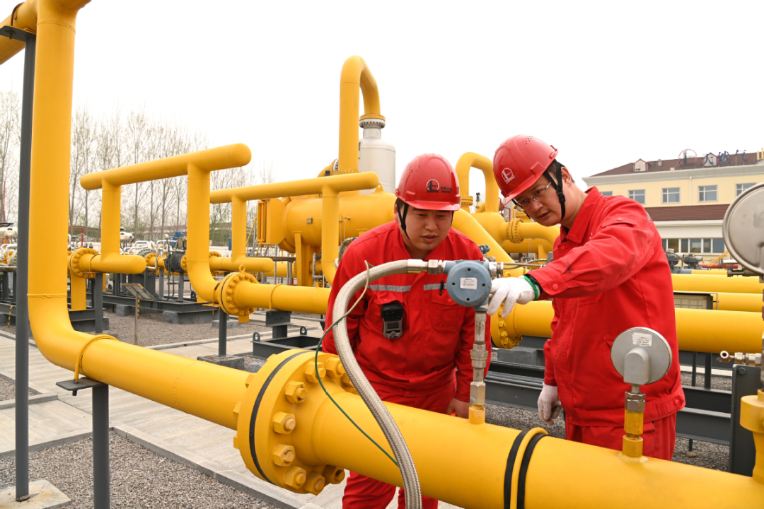
Oil & Gas Pipeline Troubleshooting & Operation Problem Solving

Course Reference

PE0909(PE8)

Course Duration/Credits
Five days/3.0 CEUs/30 PDHs

Course Date/Venue

Session(s) | Date | Venue
1 | January 26-30, 2025 | TBA Meeting Room, Taksim Square Hotel, Istanbul, Turkey
2 | May 04-08, 2025 | Business Meeting, Crowne Plaza Al Khobar, Al Khobar, KSA
3 | August 25-29, 2025 | Fujairah Meeting Room, Grand Millennium Al Wahda Hotel, Abu Dhabi, UAE
4 | December 07-11, 2025 | Boardroom 1, Elite Byblos Hotel Al Barsha, Sheikh Zayed Road, Dubai, UAE

Course Description

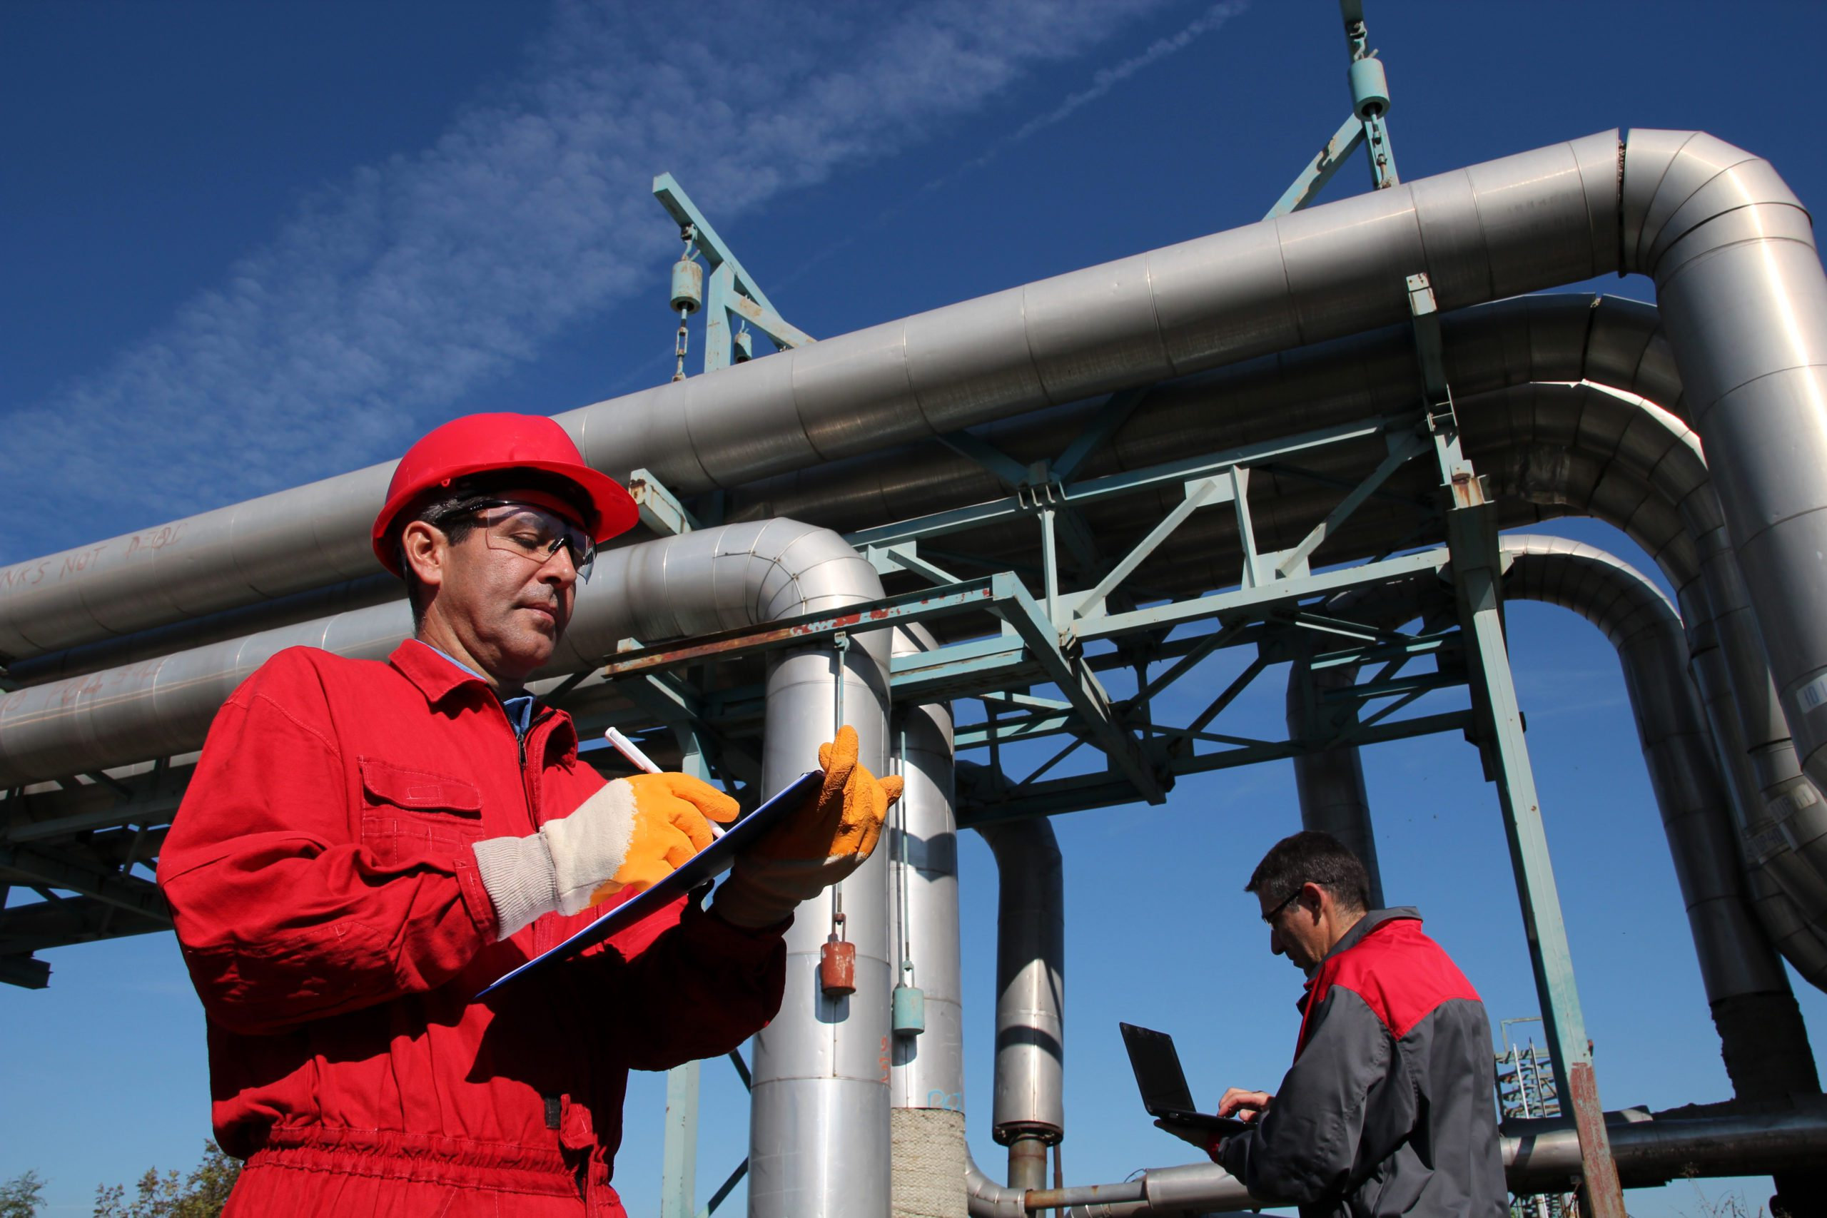

This practical and highly-interactive course includes various practical sessions and exercises. Theory learnt will be applied using our state-of-the-art simulators.

This course is designed to cover the important area of pipeline troubleshooting and operation problem solving in the oil and gas fields. It will address the many operation problems that face the field operations engineers including optimizing the pipeline system in both offshore and onshore oil and gas fields.

The course will provide an understanding of flow phenomena that can help the participants avoiding problems such as hydrate formation, pressure (surge) waves or high viscosity liquid flow failure. It will address several critical problems in achieving pipeline flow assurance. The focus of this course is on potential challenges to pipeline operations including surge, corrosion, hydrate formation, wax deposition, multiphase fluids and slugging. The causes from these problems, design solutions and operational responses will be an integral part of the course.

The course aims to determine the importance of optimum pressure control performance on pipeline operations as at the end of the program, the participant will acquire practical knowledge that will be immediately applied including the optimizing of a pipeline from start to end covering all the various elements.

The course will focus on the practical aspects of pipeline optimization in addition to the theoretical knowledge with regards to pipeline engineering. The process of pipeline optimizing will be assessed by means of an example project.

Course Objectives
Upon the successful completion of this course, each participant will be able to:-
- Apply and gain an in-depth knowledge on petroleum pipeline operation and optimization
- Identify and employ fluid characteristics and behavior in the design and operations of pipeline systems
- Assess the physical behavior of the key flow assurance and integrity challenges including corrosion, hydrate formation, transient behavior and wax deposition
- Evaluate mechanical integrity of pipeline
- Discuss the asphaltene prediction, scale precipitation and sand production
- Explain how to evaluate the effectiveness of pigging operations and leak detection systems
- Define the roles and uses of supervisory control and data acquisitions systems (SCADA) in flow assurance and startup and shutdown issues

Exclusive Smart Training Kit - H-STK®
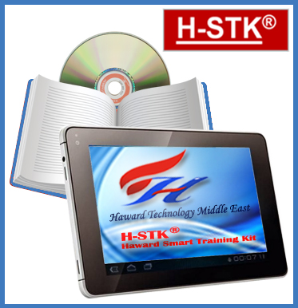
Participants of this course will receive the exclusive “Haward Smart Training Kit” (H-STK®). The H-STK® consists of a comprehensive set of technical content which includes electronic version of the course materials conveniently saved in a Tablet PC

Who Should Attend
This course provides an overview of all significant aspects and considerations of pipeline for those who are involved in the operation, optimization and problem solving of pipeline systems in oil and gas fields. Field operation engineers, process engineers, pipeline engineers, station supervisors and SCADA pipeline staff will gain an excellent knowledge from the practical and problem solving aspects of this course.

Training Methodology
All our Courses are including Hands-on Practical Sessions using equipment, State-of-the-Art Simulators, Drawings, Case Studies, Videos and Exercises. The courses include the following training methodologies as a percentage of the total tuition hours: -

30% Lectures
20% Practical Workshops & Work Presentations
30% Hands-on Practical Exercises & Case Studies
20% Simulators (Hardware & Software) & Videos

In an unlikely event, the course instructor may modify the above training methodology before or during the course for technical reasons.

Course Certificate(s)
Internationally recognized certificates will be issued to all participants of the course who completed a minimum of 80% of the total tuition hours.

Certificate Accreditations
Certificates are accredited by the following international accreditation organizations: -
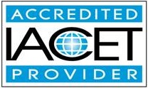
● The International Accreditors for Continuing Education and Training (IACET - USA)

Haward Technology is an Authorized Training Provider by the International Accreditors for Continuing Education and Training (IACET), 2201 Cooperative Way, Suite 600, Herndon, VA 20171, USA. In obtaining this authority, Haward Technology has demonstrated that it complies with the ANSI/IACET 2018-1 Standard which is widely recognized as the standard of good practice internationally. As a result of our Authorized Provider membership status, Haward Technology is authorized to offer IACET CEUs for its programs that qualify under the ANSI/IACET 2018-1 Standard.

Haward Technology’s courses meet the professional certification and continuing education requirements for participants seeking Continuing Education Units (CEUs) in accordance with the rules & regulations of the International Accreditors for Continuing Education & Training (IACET). IACET is an international authority that evaluates programs according to strict, research-based criteria and guidelines. The CEU is an internationally accepted uniform unit of measurement in qualified courses of continuing education.

Haward Technology Middle East will award 3.0 CEUs (Continuing Education Units) or 30 PDHs (Professional Development Hours) for participants who completed the total tuition hours of this program. One CEU is equivalent to ten Professional Development Hours (PDHs) or ten contact hours of the participation in and completion of Haward Technology programs. A permanent record of a participant’s involvement and awarding of CEU will be maintained by Haward Technology. Haward Technology will provide a copy of the participant’s CEU and PDH Transcript of Records upon request.

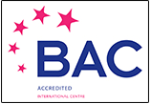
● British Accreditation Council (BAC)

Haward Technology is accredited by the British Accreditation Council for Independent Further and Higher Education as an International Centre. BAC is the British accrediting body responsible for setting standards within independent further and higher education sector in the UK and overseas. As a BAC-accredited international centre, Haward Technology meets all of the international higher education criteria and standards set by BAC.

Accommodation
Accommodation is not included in the course fees. However, any accommodation required can be arranged at the time of booking.

Course Instructor(s)
This course will be conducted by the following instructor(s). However, we have the right to change the course instructor(s) prior to the course date and inform participants accordingly:


Mr. Mervyn Frampton, BSc, PMI-PMP, CSSBB, is a Senior Process Engineer with over 40 years of industrial experience within the Oil & Gas, Refinery, Petrochemical and Utilities industries. His expertise lies extensively in the areas of Operations Asset Integrity, Flare, Blowdown & Pressure Relief Systems Operation, Maintenance & Troubleshooting, Dynamics of the Petrochemicals Industry, Understanding the Global Petrochemical Industry, Petrochemicals Analysis, Natural Gas Liquids & Petrochemical Industry and Markets, Refinery & Process Industry, Refinery Optimization, Refinery Operations Troubleshooting, Refinery Production Operations, Refinery Process Safety, Petroleum Refinery Process, Asset Operational Integrity, Refinery Induction, Crude Distillation, Crude Oil Properties, Distillation Column Operation & Control, Oil Movement Storage & Troubleshooting, Process Equipment Design, Applied Process Engineering Elements, Process Plant Optimization, Revamping & Debottlenecking, Process Plant Troubleshooting & Engineering Problem Solving, Process Plant Monitoring, Catalyst Selection & Production Optimization, Operations Abnormalities & Plant Upset, Process Plant Start-up & Commissioning, Clean Fuel Technology & Standards, Oil & Gas Field Commissioning Techniques, Pressure Vessel Operation, Gas Processing, Chemical Engineering, Process Reactors Start-Up & Shutdown, Gasoline Blending for Refineries, Urea Manufacturing Process Technology, Continuous Catalytic Reformer (CCR), De-Sulfurization Technology, Advanced Operational & Troubleshooting Skills, Principles of Operations Planning, Rotating Equipment Maintenance & Troubleshooting, Hazardous Waste Management & Pollution Prevention, Heat Exchangers & Fired Heaters Operation & Troubleshooting, Energy Conservation Skills, Catalyst Technology, Chemical Analysis, Process Plant, Commissioning & Start-Up, Alkylation, Hydrogenation, Dehydrogenation, Isomerization, Hydrocracking & De-Alkylation, Fluidized Catalytic Cracking, Catalytic Hydrodesulphuriser, Kerosene Hydrotreater, Thermal Cracker, Catalytic Reforming, Polymerization, Polyethylene, Polypropylene, Pilot Water Treatment Plant, Gas Cooling, Cooling Water Systems, Effluent Systems, Material Handling Systems, Gasifier, Gasification, Coal Feeder System, Sulphur Extraction Plant, Acid Plant Revamp and Crude Pumping. Further, he is also well-versed in HSE Leadership, Project and Programme Management, Project Coordination, Project Cost & Schedule Monitoring, Control & Analysis, Team Building, Relationship Management, Quality Management, Performance Reporting, Project Change Control, Commercial Awareness and Risk Management.

During his career life, Mr. Frampton held significant positions as the Site Engineering Manager, Senior Project Manager, Project Engineering Manager, Construction Manager, Site Manager, Area Manager, Procurement Manager, Factory Manager, Technical Services Manager, Senior Project Engineer, Project Engineer, Assistant Project Manager, Handover Coordinator and Engineering Coordinator from various international companies such as the Fluor Daniel, KBR South Africa, ESKOM, MEGAWATT PARK, CHEMEPIC, PDPS, CAKASA, Worley Parsons, Lurgi South Africa, Sasol, Foster Wheeler, Bosch & Associates, BCG Engineering Contractors, Fina Refinery, Sapref Refinery, Secunda Engine Refinery just to name a few.

Mr. Frampton has a Bachelor’s degree in Industrial Chemistry from The City University in London. Further, he is a Certified Project Management Professional (PMI-PMP), a Certified Six Sigma Black Belt (CSSBB) from The International Six Sigma Institute, a Certified Internal Verifier/Trainer/Assessor by the Institute of Leadership & Management (ILM), a Certified Instructor/Trainer and has delivered numerous trainings, courses, workshops, conferences and seminars internationally.

Course Fee

Istanbul | US$ 6,000 per Delegate + VAT. This rate includes H-STK® (Haward Smart Training Kit), buffet lunch, coffee/tea on arrival, morning & afternoon of each day.
Al Khobar | US$ 5,500 per Delegate + VAT. This rate includes H-STK® (Haward Smart Training Kit), buffet lunch, coffee/tea on arrival, morning & afternoon of each day.
Abu Dhabi | US$ 5,500 per Delegate + VAT. This rate includes H-STK® (Haward Smart Training Kit), buffet lunch, coffee/tea on arrival, morning & afternoon of each day.
Dubai | US$ 5,500 per Delegate + VAT. This rate includes H-STK® (Haward Smart Training Kit), buffet lunch, coffee/tea on arrival, morning & afternoon of each day.

Course Program
The following program is planned for this course. However, the course instructor(s) may modify this program before or during the course for technical reasons with no prior notice to participants. Nevertheless, the course objectives will always be met:

Day 1
0730 – 0800 | Registration & Coffee
0800 – 0815 | Welcome & Introduction
0815 – 0830 | PRE-TEST
0830 – 0930 | Introduction to Oil & Gas Fluid Transport Properties
0930 – 0945 | Break
0945 – 1230 | Fluid Property Data & Phase Determination
1230 - 1245 | Break
1245 – 1315 | Fluid Flow Analysis – Single & Multiphase
1315 – 1420 | Slug Formation & Prediction
1420 – 1430 | Recap
1430 | Lunch & End of Day One

Day 2
0730 – 0900 | Surge Analysis
0900 – 0915 | Break
0915 – 1030 | Corrosion – Internal & External
1030 – 1230 | Hydrate Formation & Prevention
1230 - 1245 | Break
1245 – 1315 | Wax Formation & Deposition including Prevention & Remediation
1315 – 1420 | Asphaltene Prediction, Scale Precipitation & Sand Production
1420 - 1430 | Recap
1430 | Lunch & End of Day Two

Day 3
0730 - 0900 | Pigging Operations
0900 - 0915 | Break
0915– 1230 | Leak Determination Methods & SCADA
1230 - 1245 | Break

1245– 1315 | Startup/Shutdown Issues
1315 – 1420 | Pipe Flow Theory & Hydraulic Analyses
1420 – 1430 | Recap
1430 | Lunch & End of Day Three

Day 4
0730 – 0915 | Process of Optimizing of a Pipeline
0900 - 0915 | Break
0915 – 1230 | Economic Analysis, Life-Cycle Analysis & Optimization of Pipeline Systems
1230 - 1245 | Break
1245 – 1315 | Network Analysis & Layout
1315 – 1420 | Structural Analysis of Pipes
1420 - 1430 | Recap
1430 | Lunch & End of Day Four

Day 5
0730 – 0900 | Dynamic Analyses
0900– 0915 | Break
0915 – 1200 | Pipeline Component Design
1200 - 1215 | Break
1215 – 1315 | Minimization of Pipeline Running Cost
1315– 1415 | Planning of Cost Efficient Operations
1345 - 1400 | Course Conclusion
1400 - 1415 | POST-TEST
1415 - 1430 | Presentation of Course Certificates
1430 | Lunch & End of Course

Simulator (Hands-on Practical Sessions)
Practical sessions will be organized during the course for delegates to practice the theory learnt. Delegates will be provided with an opportunity to carryout various exercises using the “ASPEN HYSYS” simulator.

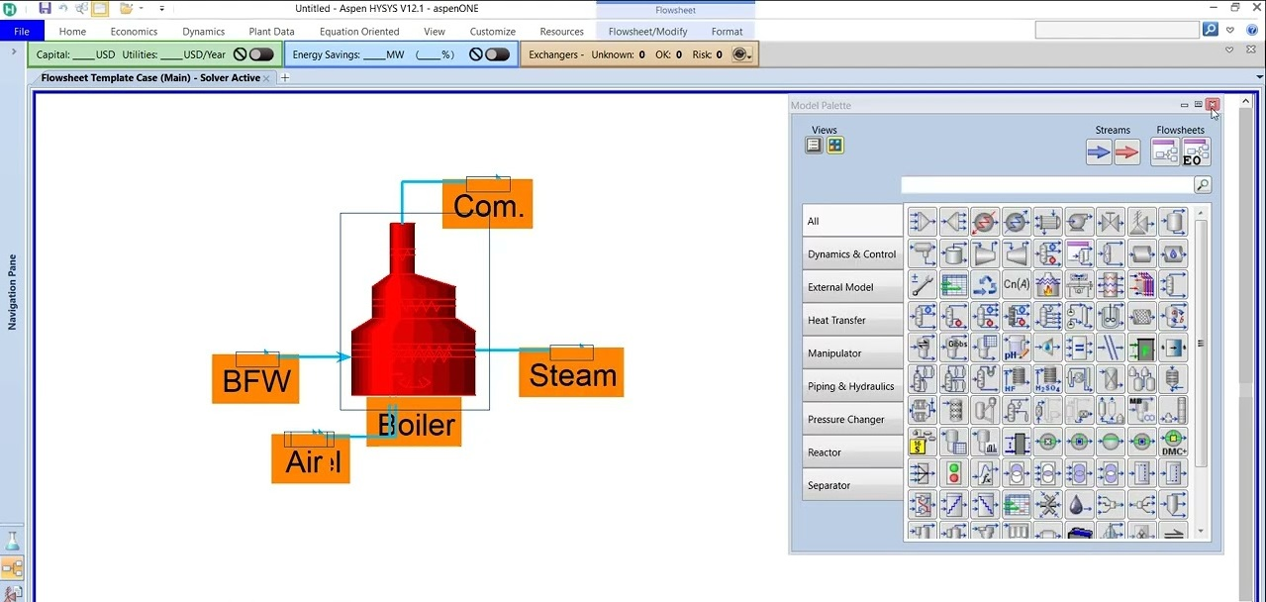

ASPEN HYSYS V12.1 Simulator

Course Coordinator
Mari Nakintu, Tel: +971 2 30 91 714, Email: mari1@haward.org

