COURSE OVERVIEW IE0633
Certified Mechanical Measurement Tools & Instruments

Course Title


Certified Mechanical Measurement Tools & Instruments

Course Reference
IE0633


Course Duration/Credits
Five days/3.0 CEUs/30 PDHs

Course Date/Venue
Session(s) | Date | Venue
1 | February 16-20, 2025 | Al Khobar Meeting Room, Hilton Garden Inn, Al Khobar, KSA
2 | May 11-15, 2025 | Oryx Meeting Room, Double Tree by Hilton Al Saad, Doha, Qatar
3 | September 15-19, 2025 | Ajman Meeting Room, Grand Millennium Al Wahda Hotel, Abu Dhabi, UAE
4 | December 07-11, 2025 | Boardroom 1, Elite Byblos Hotel Al Barsha, Sheikh Zayed Road, Dubai, UAE
Course Description
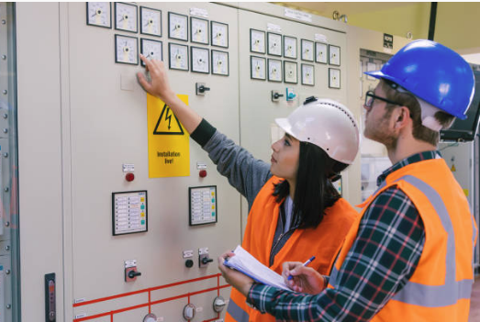


This practical and highly-interactive course includes real-life case studies and exercises where participants will be engaged in a series of interactive small groups and class workshops.

This course is designed to provide participants with a detailed and up-to-date overview of mechanical measurement tools and instruments. It covers the classification of measuring instruments and methods of measurements; selection of the proper instruments; the principles of measuring instruments; and the technical specifications of measuring instruments.

During this interactive course, participants will learn the classification of gauges and the engineer’s steel ruler; the callipers and vernier callipers; the errors and precautions of using callipers; and the vernier height, depth gauge, micrometers, sine bar, sine table, surface plate and straight edge.

Course Objectives
Upon the successful completion of this course, each participant will be able to:-
- Apply and gain a comprehensive knowledge on mechanical measurement tools and instruments
- Classify the measuring instruments and methods of measurements
- Select proper instruments and discuss the principles of measuring instruments
- Define and discuss technical specifications of measuring instruments
- Classify gauges and describe the engineer’s steel ruler
- Identify callipers and vernier callipers as well as discuss the errors and precautions of using callipers
- Determine vernier height and depth gauge, micrometers, sine bar, sine table, surface plate and straight edge

Exclusive Smart Training Kit - H-STK®
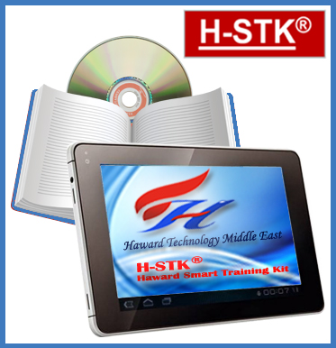
Participants of this course will receive the exclusive “Haward Smart Training Kit” (H-STK®). The H-STK® consists of a comprehensive set of technical content which includes electronic version of the course materials conveniently saved in a Tablet PC.

Who Should Attend
This course provides an overview of all significant aspects and considerations of mechanical measurement tools and instruments for mechanical, electrical and instrumentation engineers and other technical staff.

Accommodation
Accommodation is not included in the course fees. However, any accommodation required can be arranged at the time of booking.

Course Fee
Al Khobar | US$ 5,500 per Delegate + VAT. This rate includes H-STK® (Haward Smart Training Kit), buffet lunch, coffee/tea on arrival, morning & afternoon of each day.
Doha | US$ 6,000 per Delegate. This rate includes H-STK® (Haward Smart Training Kit), buffet lunch, coffee/tea on arrival, morning & afternoon of each day.
Abu Dhabi | US$ 5,500 per Delegate + VAT. This rate includes H-STK® (Haward Smart Training Kit), buffet lunch, coffee/tea on arrival, morning & afternoon of each day.
Dubai | US$ 5,500 per Delegate + VAT. This rate includes H-STK® (Haward Smart Training Kit), buffet lunch, coffee/tea on arrival, morning & afternoon of each day.

Course Certificate(s)
Internationally recognized certificates will be issued to all participants of the course who completed a minimum of 80% of the total tuition hours.

Certificate Accreditations
Certificates are accredited by the following international accreditation organizations: -
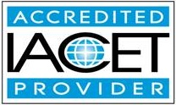
● The International Accreditors for Continuing Education and Training (IACET - USA)

Haward Technology is an Authorized Training Provider by the International Accreditors for Continuing Education and Training (IACET), 2201 Cooperative Way, Suite 600, Herndon, VA 20171, USA. In obtaining this authority, Haward Technology has demonstrated that it complies with the ANSI/IACET 2018-1 Standard which is widely recognized as the standard of good practice internationally. As a result of our Authorized Provider membership status, Haward Technology is authorized to offer IACET CEUs for its programs that qualify under the ANSI/IACET 2018-1 Standard.

Haward Technology’s courses meet the professional certification and continuing education requirements for participants seeking Continuing Education Units (CEUs) in accordance with the rules & regulations of the International Accreditors for Continuing Education & Training (IACET). IACET is an international authority that evaluates programs according to strict, research-based criteria and guidelines. The CEU is an internationally accepted uniform unit of measurement in qualified courses of continuing education.

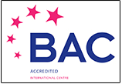
Haward Technology Middle East will award 3.0 CEUs (Continuing Education Units) or 30 PDHs (Professional Development Hours) for participants who completed the total tuition hours of this program. One CEU is equivalent to ten Professional Development Hours (PDHs) or ten contact hours of the participation in and completion of Haward Technology programs. A permanent record of a participant’s involvement and awarding of CEU will be maintained by Haward Technology. Haward Technology will provide a copy of the participant’s CEU and PDH Transcript of Records upon request.
● British Accreditation Council (BAC)

Haward Technology is accredited by the British Accreditation Council for Independent Further and Higher Education as an International Centre. BAC is the British accrediting body responsible for setting standards within independent further and higher education sector in the UK and overseas. As a BAC-accredited international centre, Haward Technology meets all of the international higher education criteria and standards set by BAC.

Course Instructor(s)
This course will be conducted by the following instructor(s). However, we have the right to change the course instructor(s) prior to the course date and inform participants accordingly:

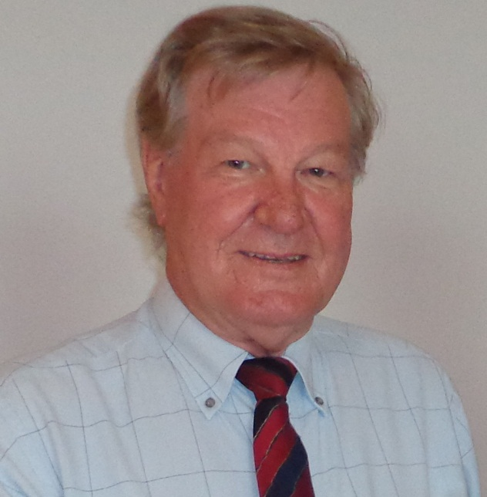
Mr. Sydney Thoresson, PE, BSc, is a Senior Electrical & Instrumentation Engineer with over 40 years of extensive experience within the Petrochemical, Utilities, Oil, Gas and Power industries. His specialization highly evolves in Electrical Drawing and Schematics, Hazardous Area Classification, Intrinsic Safety, Liquid & Gas Flowmetering, Custody Measurement, Ultrasonic Flowmetering, Loss Control, Gas Measurement, Process Control Instrumentation, Compressor Control & Protection, Control Systems, Programmable Logic Controllers (PLC), SCADA, Distributed Control Systems (DCS) especially in Honeywell DCS, H&B DCS, Modicon, Siemens, Telemecanique, Wonderware and Adrioit. Moreover, he has vast experience in the field of Safety Instrumented Systems (SIS), Safety Integrity Level (SIL), Emergency Shutdown (ESD), Flowmetering & Custody Measurement, Multiphase Flowmetering, Measurement and Control, Mass Measuring System Batching (Philips), Arc Furnace Automation-Ferro Alloys, Walking Beam Furnace, Blast Furnace, Billet Casting Station, Cement Kiln Automation, Factory Automation and Quality Assurance Accreditation (ISO 9000 and Standard BS 5750).

During Mr. Thoresson’s career life, he has gained his thorough and practical experience through various challenging positions such as a Project Manager, Contracts Manager, Managing Director, Technical Director, Divisional Manager, Plant Automation Engineer, Senior Consulting Engineer, Senior Systems Engineer, Consulting Engineer, Service Engineer and Section Leader from several international companies such as Philips, FEDMIS, AEG, DAVY International, BOSCH Instrumentation and Control, Billiton, Endress/Hauser, Petronet, Iscor, Spoornet, Eskom and Afrox.

Mr. Thoresson is a Registered Professional Engineering Technologist and has a National Higher Diploma (NHD) & a National Diploma in Radio Engineering from the Witwatersrand Technikon. Further, he is a Certified Instructor/Trainer, a Certified Internal Verifier/Assessor/Trainer by the Institute of Leadership & Management (ILM), an active member of the International Society of Automation (ISA) and the Society for Automation, Instrumentation, Measurement and Control (SAIMC).

Training Methodology
All our Courses are including Hands-on Practical Sessions using equipment, State-of-the-Art Simulators, Drawings, Case Studies, Videos and Exercises. The courses include the following training methodologies as a percentage of the total tuition hours:-

30% Lectures
20% Practical Workshops & Work Presentations
30% Hands-on Practical Exercises & Case Studies
20% Simulators (Hardware & Software) & Videos

In an unlikely event, the course instructor may modify the above training methodology before or during the course for technical reasons.

Course Program
The following program is planned for this course. However, the course instructor(s) may modify this program before or during the course for technical reasons with no prior notice to participants. Nevertheless, the course objectives will always be met:

Day 1
0730 – 0800 | Registration & Coffee
0800 – 0815 | Welcome & Introduction
0815 – 0830 | PRE-TEST
0830 – 0930 | Classification of Measuring Instruments
0930 – 0945 | Break
0945 – 1100 | Classification of Methods of Measurements
1100 – 1215 | Selection of Instruments
1215 – 1230 | Break
1230 – 1420 | Principle of Measuring Instruments
1420 – 1430 | Recap
1430 | Lunch & End of Day One

Day 2
0730 – 0930 | Definitions
0930 – 0945 | Break
0945 – 1100 | Technical Specifications of Measuring Instruments
1100 – 1215 | Gauges
1215 – 1230 | Break
1230 – 1420 | Classification of Gauges
1420 – 1430 | Recap
1430 | Lunch & End of Day Two

Day 3
0730 – 0930 | Engineer’s Steel Ruler
0930 – 0945 | Break
0945 – 1100 | Calipers
1100 – 1215 | Vernier Calipers
1215 – 1230 | Break
1230 – 1420 | Errors in Calipers
1420 – 1430 | Recap
1430 | Lunch & End of Day Three

Day 4
0730 – 0930 | Precautions in Using Calipers
0930 – 0945 | Break
0945 – 1100 | Vernier Height and Depth Gauge
1100 – 1215 | Micrometers
1215 – 1230 | Break
1230 – 1420 | Sine Bar
1420 – 1430 | Recap
1430 | Lunch & End of Day Four

Day 5
0730 – 0930 | Sine Table
0930 – 0945 | Break
0945 – 1100 | Surface Plate
1100 – 1215 | Straight Edge
1215 – 1230 | Break
1230 – 1345 | Straight Edge (cont’d)
1345 – 1400 | Course Conclusion
1400 – 1415 | POST-TEST
1415 – 1430 | Presentation of Course Certificates
1430 | Lunch & End of Course

Practical Sessions
This practical and highly-interactive course includes real-life case studies and exercises:-

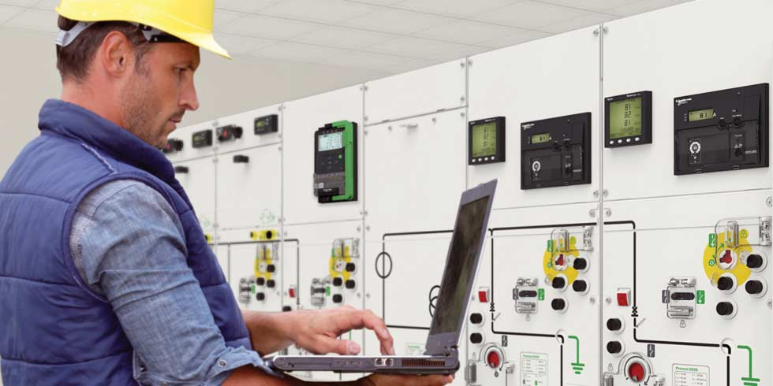

Course Coordinator
Mari Nakintu, Tel: +971 2 30 91 714, Email: mari1@haward.org

