COURSE OVERVIEW PE0785
Refinery Operational Economics, Planning & Profitability

Course Title

Refinery Operational Economics, Planning & Profitability

Course Date/Venue

December 07-11, 2025/TBA Meeting Room, Hilton Kuwait Resort, Mangaf, Kuwait City, Kuwait


Course Reference
PE0785

Course Duration/Credits
Five days/3.0 CEUs/30 PDHs

Course Description

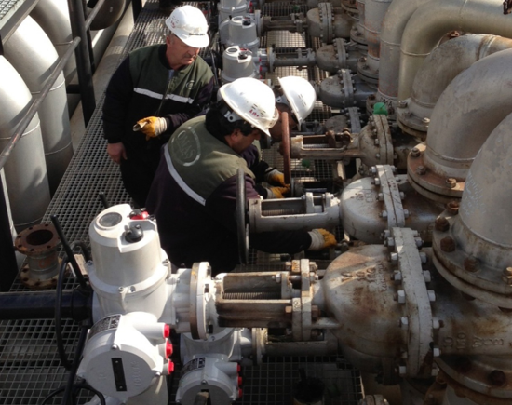

This practical and highly-interactive course includes various practical sessions and exercises. Theory learnt will be applied using the “MS Excel” applications.

The petroleum refining industry processes crude oil and produces a variety of products that are used in the transportation, residential, commercial, and industrial sectors of the economy.

In 2006, over two thirds of refinery output went to transportation uses, nearly a quarter went to industrial uses, and the remainder was used in residences, commercial activities, and electricity generation. The transportation sector remains the most heavily dependent on petroleum, drawing over 95% of its fuel needs from refineries.

Because the refining industry plays such a key role in providing energy for the economy, its structure and economic condition are matters of national interest. In recent years the industry has undergone significant change.

The traditional industry model, based on ownership by vertically integrated oil companies with profitability viewed within the context of a linked supply chain, has been altered by companies and joint ventures whose primary business is refining. Increasingly, the business model for these firms, as well as the integrated oil companies, is the standalone profit center.

Refiners now must earn market rates of return for investors, as well as returns sufficient to make investments in expansion, technological improvements, possible business restructuring, and to meet environmental regulations, both with respect to refined product specifications and refinery site operations and expansion.

The aim of this course is to provide participants with a complete and up-to-date overview of the refinery operational economics, planning and profitability. Upon the successful completion of this course, participant will gain a satisfactory understanding of the concepts of operational profitability, refinery configuration, planning objectives and tools, key crude and product qualities, crude and product pricing, practical refinery modelling, market dynamics, managing risk, performance measures and benchmarking. Actual case studies from around the world will be demonstrated to highlight the topics discussed.

Course Objectives
Upon the successful completion of this course, each participant will be able to:-
- Apply a comprehensive knowledge in operational economics, planning and profitability of modern oil refineries
- Discuss the concepts of operational profitability including gross refining margin (GRM), net refining margin and contribution margin
- Determine refinery configuration covering topping, hydroskimming, cracking, full conversion and niche products
- Identify and carryout planning objectives including production plans, selecting feedstock, feasibility, optimality, optimal product mix, marginal economics, investment opportunities and planning versus scheduling
- List the various planning tools, employ blending methods and illustrate process models
- Enumerate modeling tools covering simple stock balances (spreadsheet), linear programming (LP’s), non-linear programming (NLP’s), distributed error recursion and integer programming
- Identify the various model types pertaining to blending, multi-refinery and distribution, single refinery and time period
- Describe key crude and product qualities as well as crude and product pricing
- Illustrate practical refinery modeling covering simple LP construction, pooling problem, delta-base modeling, convexity constraints, marginal values or shadow prices, crude ranking and evaluation as well as weight and volume basis
- Recognize market dynamics covering the supply and demand vise as well as global versus local markets
- Manage risk using term contracts, hedging and risk versus reward
- Employ performance measures covering benchmark margin analysis, model validation and back-casting

Exclusive Smart Training Kit - H-STK®
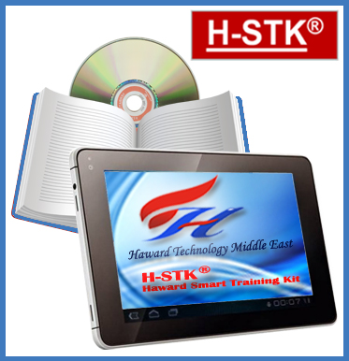
Participants of this course will receive the exclusive “Haward Smart Training Kit” (H-STK®). The H-STK® consists of a comprehensive set of technical content which includes electronic version of the course materials conveniently saved in a Tablet PC.

Who Should Attend
This course provides an overview of all significant aspects and considerations of refinery operational economics, planning and profitability. Planning engineers, process engineers, production engineers, scheduling engineers, marketing engineers and estimation engineers will definitely benefit from the practical approach of the course. Finance managers, commercial managers, estimation managers, section heads, supervisors and refineries/process plant consultants will gain an excellent knowledge from the operational aspects of this course.

Training Methodology
All our Courses are including Hands-on Practical Sessions using equipment, State-of-the-Art Simulators, Drawings, Case Studies, Videos and Exercises. The courses include the following training methodologies as a percentage of the total tuition hours:-

30% Lectures
20% Practical Workshops & Work Presentations
30% Hands-on Practical Exercises & Case Studies
20% Simulators (Hardware & Software) & Videos

In an unlikely event, the course instructor may modify the above training methodology before or during the course for technical reasons.

Course Fee
US$ 5,500 per Delegate. This rate includes H-STK® (Haward Smart Training Kit), buffet lunch, coffee/tea on arrival, morning & afternoon of each day.

Accommodation
Accommodation is not included in the course fees. However, any accommodation required can be arranged at the time of booking.

Course Certificate(s)
Internationally recognized certificates will be issued to all participants of the course who completed a minimum of 80% of the total tuition hours.

Certificate Accreditations

Certificates are accredited by the following international accreditation organizations:-
● The International Accreditors for Continuing Education and Training (IACET - USA)

Haward Technology is an Authorized Training Provider by the International Accreditors for Continuing Education and Training (IACET), 2201 Cooperative Way, Suite 600, Herndon, VA 20171, USA. In obtaining this authority, Haward Technology has demonstrated that it complies with the ANSI/IACET 2018-1 Standard which is widely recognized as the standard of good practice internationally. As a result of our Authorized Provider membership status, Haward Technology is authorized to offer IACET CEUs for its programs that qualify under the ANSI/IACET 2018-1 Standard.

Haward Technology’s courses meet the professional certification and continuing education requirements for participants seeking Continuing Education Units (CEUs) in accordance with the rules & regulations of the International Accreditors for Continuing Education & Training (IACET). IACET is an international authority that evaluates programs according to strict, research-based criteria and guidelines. The CEU is an internationally accepted uniform unit of measurement in qualified courses of continuing education.

Haward Technology Middle East will award 3.0 CEUs (Continuing Education Units) or 30 PDHs (Professional Development Hours) for participants who completed the total tuition hours of this program. One CEU is equivalent to ten Professional Development Hours (PDHs) or ten contact hours of the participation in and completion of Haward Technology programs. A permanent record of a participant’s involvement and awarding of CEU will be maintained by Haward Technology. Haward Technology will provide a copy of the participant’s CEU and PDH Transcript of Records upon request.
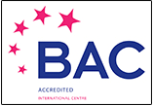
● British Accreditation Council (BAC)

Haward Technology is accredited by the British Accreditation Council for Independent Further and Higher Education as an International Centre. BAC is the British accrediting body responsible for setting standards within independent further and higher education sector in the UK and overseas. As a BAC-accredited international centre, Haward Technology meets all of the international higher education criteria and standards set by BAC.

Course Instructor(s)
This course will be conducted by the following instructor(s). However, we have the right to change the course instructor(s) prior to the course date and inform participants accordingly:

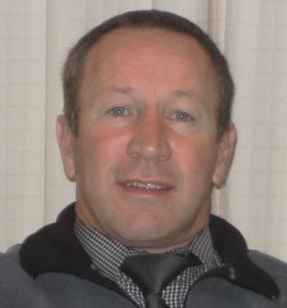
Mr. Pete Du Plessis, MSc, BSc, is a Senior Process & Safety Engineer within the Oil, Gas and Petrochemical industries. His expertise widely covers in the areas of Process Plant Troubleshooting, Engineering Problem Solving, Process Plant Optimization Technology & Continuous Improvement, Refinery Operational Planning & Profitability, Process Plant Rehabilitation, Revamping & Debottlenecking, Chemical Plants Troubleshooting, Flare Relief Systems, Risk Assessment within Production Operation, Hazard Identification, Safety Auditing, Site Inspection, Quantified Risk Assessment (QRA), Process Hazard Analysis (PHA), Process Safety Management (PSM), HAZOP Studies & Leadership, FMEA, Waste Management, Industrial Effluents, Chemical Handling, Emergency Response Services, HAZCOM, HAZWOPER and HAZMAT with over 30 years of practical experience in the process industry. His wide experience also includes Environmental Management (ISO 14001), Safety Management (OHSAS 18001), Quality Management (ISO 9001).

While Mr. Du Plessis has been very active in the process industry he has likewise headed Consultancy projects for major petrochemical companies. In all his projects, he utilizes a systems approach which includes risk management, process safety, health & environmental management, human behaviour and quality management. Furthermore, he has come to share his expertise through the numerous international trainings he has held on PHA, HAZOP, Risk Assessment, Handling Hazardous Materials & Chemicals, Petroleum Products Handling & Transportation. Moreover, he completed various assignments as a consultant, trainer, facilitator, auditor & designer and conducted numerous licensed international Safety, Technology and Auditing Awareness & Implementing training courses including IMS, ISO 9001, ISO 14001, ISO 27001, ISO 17799, OHSAS 18001 audits & assessments. With his accomplishments and achievements, he had been a Safety Superintendent, Senior Safety Official and Senior Process Controller for several international petrochemical companies.

Mr. Plessis has Bachelor’s degree with Honours in Industrial Engineering & Management. Further, he has gained Diploma in Quality & Production Management. He is also a Certified Assessor & Moderator with the Manufacturing, Engineering & Related Services Education and Training Authority (MERSETA), a Certified Trainer/Assessor by the Institute of Leadership & Management (ILM) and a Certified Instructor/Trainer by the APICS. He has further delivered numerous trainings, courses, seminars, conferences and workshops internationally.

Course Program
The following program is planned for this course. However, the course instructor(s) may modify this program before or during the course for technical reasons with no prior notice to participants. Nevertheless, the course objectives will always be met:

Day 1: Sunday, 07th of December 2025
0730 – 0745 | Registration & Coffee
0745 – 0800 | Welcome & Introduction
0800 – 0815 | PRE-TEST
0815 – 0900 | Concepts of Operational Profitability  Gross Refining Margin (GRM) ● Net Refining Margin ● Contribution Margin
0900 – 0930 | Refinery Configuration  Topping ● Hydroskimming ● Cracking (FCC & Hydrocracking)
0930 – 0945 | Break
0945 – 1215 | Refinery Configuration (cont’d)  Full Conversion (Coking) ● Niche Products (Lubes, Asphalt, Solvents, Aromatics, other Petrochemicals)
1215 – 1230 | Break
1230 – 1420 | Case Study
1420 – 1430 | Recap  Using this Course Overview, the Instructor(s) will Brief Participants about the Topics that were Discussed Today and Advise Them of the Topics to be Discussed Tomorrow
1430 | Lunch & End of Day One

Day 2: Monday, 08th of December 2025
0730 – 0930 | Planning Objectives  Production Plans (Unit Operating Goals, Blending Operations) ● Feedstock Selection ● Feasibility ● Optimality (Minimum Cost, Maximum Profit)
0930 – 0945 | Break
0945 – 1100 | Planning Objectives (cont’d)  Optimal Product Mix ● Marginal Economics ● Investment Opportunities ● Planning versus Scheduling
1100 – 1215 | Planning Tools  Blending Methods (Linear (Volume/Weight), Blending Indices, Interaction Coefficients) ● Process Models (Fixed Yield, Operational Modes, Simulation)
1215 – 1230 | Break
1230 – 1420 | Planning Tools (cont’d)  Modeling Tools (Simple Stock Balances (Spreadsheet), Linear Programming (LP’s), Feasibility, Linear Relationships, Non-Linear Programming (NLP’s), Feasibility, Local Optima, Distributed Error Recursion & Integer Programming) ● Model Types (Blending, Single Refinery, Multi-Refinery and Distribution & Time Period)
1420 – 1430 | Recap  Using this Course Overview, the Instructor(s) will Brief Participants about the Topics that were Discussed Today and Advise Them of the Topics to be Discussed Tomorrow
1430 | Lunch & End of Day Two

Day 3: Tuesday, 09th of December 2025
0730 – 0930 | Key Crude & Product Qualities  Sulfur & Gravity ● Other Properties
0930 – 0945 | Break
0945 – 1100 | Key Crude & Product Qualities (cont’d)  Environmental Regulations
1100 – 1215 | Crude & Product Pricing  Pricing Basis (FOB, CIF & Import Parity)
1215 – 1230 | Break
1230 – 1420 | Case Study
1420 – 1430 | Recap
1430 | Lunch & End of Day Three

Day 4: Wednesday, 10th of December 2025
0730 – 0930 | Practical Refinery Modeling  Constructing a Simple LP ● The Real World is Non-Linear (The Pooling Problem, Delta-Base Modeling & Convexity Constraints) ● Marginal Values or Shadow Prices
0930 – 0945 | Break
0945 – 1100 | Practical Refinery Modeling (cont’d)  Crude Ranking & Evaluation ● Weight versus Volume Basis
1100 – 1215 | Market Dynamics  The Supply-Demand Vise ● Global versus Local Markets
1215 – 1230 | Break
1230 – 1420 | Case Study
1420 – 1430 | Recap
1430 | Lunch & End of Day Four

Day 5: Thursday, 11th of December 2025
0730 – 0930 | Managing Risk  Term Contracts ● Hedging (Futures & Arbitrage) ● Risk versus Reward
0930 – 0945 | Break
0945 – 1100 | Performance Measures  Benchmark Margin Analysis ● Model Validation
1100 – 1215 | Performance Measures (cont’d)  Back-Casting ● “The Farmer & the Bale of Hay”
1215 – 1230 | Break
1230 – 1345 | Case Study
1345 – 1400 | Course Conclusion
1400 – 1415 | POST-TEST
1415 – 1430 | Presentation of Course Certificates
1430 | Lunch & End of Course

Hands-on Practical Sessions
Practical sessions will be organized during the course for delegates to practice the theory learnt. Delegates will be provided with an opportunity to carryout various exercises using “MS-Excel” application.

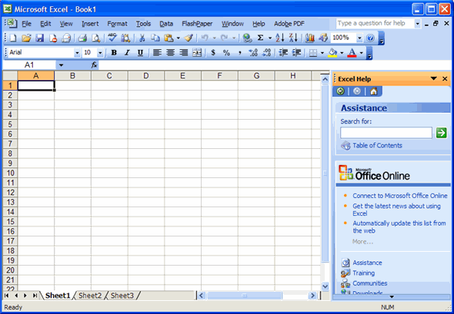

MS Excel

Course Coordinator
Mari Nakintu, Tel: +971 2 30 91 714, Email: mari1@haward.org

