COURSE OVERVIEW PE0230K1
Safe Process Units Start-Up/Shutdown & Development of Equipment Handling Over/Commissioning Procedures

Course Title


Safe Process Units Start-Up/Shutdown and Development of Equipment Handling Over/Commissioning Procedures

Course Reference
PE0230K1


Course Duration/Credits
Five days/3.0 CEUs/30 PDHs

Course Date/Venue

Session(s) | Date | Venue
1 | May 18-22, 2025 | TBA Meeting Room, Four Seasons Hotels Cairo at Nile Plaza, Cairo, Egypt
2 | September 07-11, 2025 | Boardroom 1, Elite Byblos Hotel Al Barsha, Sheikh Zayed Road, Dubai, UAE
3 | December 14-18, 2025 | Safir Meeting Room, Divan Istanbul, Turkey
4 | February 02-06, 2026 | Hampstead Meeting Room, London Marriott Hotel Regents Park, London, United Kingdom

Course Description



This practical and highly-interactive course includes various practical sessions and exercises. Theory learnt will be applied using our state-of-the-art simulators.

Plant modifications are an ongoing process throughout the life of any process plant. Reasons for modification include efforts to improve reliability, production capacity, quality, or productivity. Seamless incorporation is the key concern associated with the installation of any new equipment in an operating plant due to the high cost of process downtime. Several steps shall be taken to minimise the risk associated with the installation of new equipment such as hazard and operability studies, project management, development of redundancy plans, and commissioning of the new equipment.

Start-up and commissioning are essential activities in all process plant-modification projects and have significant implications for project success. Yet paradoxically they tend to be approached in an ad hoc manner. Commissioning is often included in project plans, so it is not that people are ignorant. However, there is usually a lack of systematic approaches to commissioning, so it is frequently left to tradespeople and plant operators to manage in whatever way they see fit. This is an undesirable situation since it results in unpredictable outcomes. In some cases it can even cause serious problems. Lack of experience in dealing with these problems has frequently resulted in prolonged and costly start-ups, caused by inadequate preparation for the events of start-up.

This course is designed to provide participants with an up-to-date overview of the start-up and commissioning of Process plants including troubleshooting of the start-up process. It includes the methodology for start-up and commissioning of process plants, which can be used when commissioning a new plant, or for modified equipment in an existing facility, or in a turnaround, shutdown or overhaul scenario. It takes the approach that commissioning is a series of checks and counter-checks to confirm every unit in the process plant is fit for purpose and suitable for operation.

During the course, each participant will gain enough skills to anticipate and avoid problems associated with start-up processes. Participants will gain a satisfactory understanding of the commissioning strategy, organizational issues, estimation of required resources, CPM planning, mechanical integrity, troubleshooting, start-up operations, technical inspection, instrumentation/control systems, HSE and other necessary knowledge associated with the process plant start-up and commissioning. Actual case studies from around the world will be demonstrated to highlight the topics discussed.

Course Objectives
Upon the successful completion of this course, each participant will be able to:-
- Apply systematic techniques in process plant start-up, commissioning and troubleshooting
- Carryout planning and preparation as well as cost estimation
- Discuss health, safety and environment, process plant start-up management and develop process plant commissioning strategy
- Conduct mechanical integrity testing and pre-commissioning, technical inspection and dynamic hydraulic testing
- Explain construction completion and the importance of machinery commissioning
- Apply start-up operations, start-up progress monitoring and control as well as determine instrumentation and control systems in commissioning process
- Demonstrate performance trials, troubleshooting and problem solving
- Implement change management including operational techniques and post commissioning audit in process plants

Exclusive Smart Training Kit - H-STK®
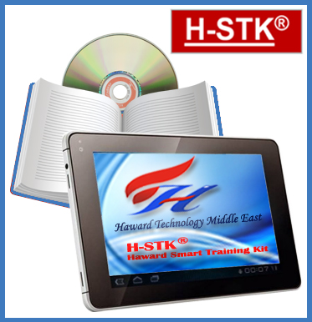
Participants of this course will receive the exclusive “Haward Smart Training Kit” (H-STK®). The H-STK® consists of a comprehensive set of technical content which includes electronic version of the course materials conveniently saved in a Tablet PC.

Who Should Attend
This course provides a complete and up-to-date overview of the process plant start-up and commissioning for those involved in the start-up operations of a process plant. This includes process engineers, team leaders, project managers, refinery managers, plant managers, section heads, plant supervisors, process engineers, maintenance staff, technical staff and contractor personnel involved in project execution and plant start-up in process industry. Mechanical, electrical, instrumentation and control engineers who are involved in process plant start-up and commissioning will also benefit from this course.

Training Methodology
All our Courses are including Hands-on Practical Sessions using equipment, State-of-the-Art Simulators, Drawings, Case Studies, Videos and Exercises. The courses include the following training methodologies as a percentage of the total tuition hours:-

30% Lectures
20% Practical Workshops & Work Presentations
30% Hands-on Practical Exercises & Case Studies
20% Simulators (Hardware & Software) & Videos

In an unlikely event, the course instructor may modify the above training methodology before or during the course for technical reasons.

Course Fee

Cairo | US$ 5,500 per Delegate + VAT. This rate includes H-STK® (Haward Smart Training Kit), buffet lunch, coffee/tea on arrival, morning & afternoon of each day.
Dubai | US$ 5,500 per Delegate + VAT. This rate includes H-STK® (Haward Smart Training Kit), buffet lunch, coffee/tea on arrival, morning & afternoon of each day.
Istanbul | US$ 6,000 per Delegate + VAT. This rate includes H-STK® (Haward Smart Training Kit), buffet lunch, coffee/tea on arrival, morning & afternoon of each day.
London | US$ 8,800 per Delegate + VAT. This rate includes H-STK® (Haward Smart Training Kit), buffet lunch, coffee/tea on arrival, morning & afternoon of each day.

Accommodation
Accommodation is not included in the course fees. However, any accommodation required can be arranged at the time of booking.

Course Certificate(s)
Internationally recognized certificates will be issued to all participants of the course who completed a minimum of 80% of the total tuition hours.

Certificate Accreditations
Certificates are accredited by the following international accreditation organizations:
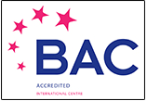

● British Accreditation Council (BAC)

Haward Technology is accredited by the British Accreditation Council for Independent Further and Higher Education as an International Centre. BAC is the British accrediting body responsible for setting standards within independent further and higher education sector in the UK and overseas. As a BAC-accredited international centre, Haward Technology meets all of the international higher education criteria and standards set by BAC.

● The International Accreditors for Continuing Education and Training (IACET - USA)

Haward Technology is an Authorized Training Provider by the International Accreditors for Continuing Education and Training (IACET), 2201 Cooperative Way, Suite 600, Herndon, VA 20171, USA. In obtaining this authority, Haward Technology has demonstrated that it complies with the ANSI/IACET 2018-1 Standard which is widely recognized as the standard of good practice internationally. As a result of our Authorized Provider membership status, Haward Technology is authorized to offer IACET CEUs for its programs that qualify under the ANSI/IACET 2018-1 Standard.

Haward Technology’s courses meet the professional certification and continuing education requirements for participants seeking Continuing Education Units (CEUs) in accordance with the rules & regulations of the International Accreditors for Continuing Education & Training (IACET). IACET is an international authority that evaluates programs according to strict, research-based criteria and guidelines. The CEU is an internationally accepted uniform unit of measurement in qualified courses of continuing education.

Haward Technology Middle East will award 3.0 CEUs (Continuing Education Units) or 30 PDHs (Professional Development Hours) for participants who completed the total tuition hours of this program. One CEU is equivalent to ten Professional Development Hours (PDHs) or ten contact hours of the participation in and completion of Haward Technology programs. A permanent record of a participant’s involvement and awarding of CEU will be maintained by Haward Technology. Haward Technology will provide a copy of the participant’s CEU and PDH Transcript of Records upon request.

Course Instructor(s)
This course will be conducted by the following instructor(s). However, we have the right to change the course instructor(s) prior to the course date and inform participants accordingly:

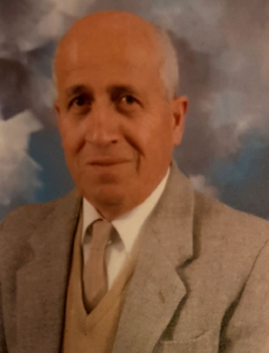
Mr. Mohammad Hamami, is a Senior Process Engineer with an extensive practical experience within the Oil, Gas, Refinery, Petrochemical and Power industries. His experience covers Clean Fuel Technology & Standards, Clean Fuel Specification, Emission Regulation, Crude Oil Production, Desulphurization, Synthesis Gas Production, Naphtha Isomerization, Diesel Fuel Additives, Storage Tanks Filtration, Fuel Quality Inspection, Process Plant Troubleshooting & Engineering Problem Solving, Process Equipment Operation, Process Plant Operation, Process Plant Start-up & Commissing, Process Plant Optimization, Oil & Gas Field Operation, Oil Movement, Storage & Troubleshooting, Petroleum Refinery Process, Process Reactor Operation & Troubleshooting, LPG Oil & Gas Operation & Troubleshooting, Crude Oil & LNG Storage, LNG & LPG Plants Gas Processing, Refinery Process Operations Technology, Liquid Bulk Cargo Handling, Gas Conditioning & Processing Technology, Distillation Column Design & Operation and Gasoline & Diesel Fuel Technology. Further he is also well-versed in Refinery Operational Economics & Profitablity, Aromatics Manufacturing Process, Hydrogen Production Operation, Steam Reforming Technology, Gas Treating, Hydro-treating & Hydro-Cracking, Catalyst Material Handling, Gas Sweetening & Sulfur Recovery, Hydro Carbon Dew Point (HCDP) Control, Heat Exchangers & Fired Heaters, Amine Gas Sweetening, Plastic Additives Selection & Application, Crude & Vaccum Process Technology, Flare & Pressure Relief Systems, Stock Management & Tank Dipping Calculation, NGL Recovery & Fractionation, Refrigerant & NGL Extraction and Catalytic Craking & Reforming.

During his long professional carreer, Mr. Mohammad worked as a Refinery Manager, Operations Manager, Section Head/Superintendent and Process Engineer for Process Units, Utilities & Oil Movement in various companies. He has been responsible for a number of technological-driven world-scale hydrocarbon processing projects from beginning to successful start-up.

Mr. Mohammad has a Bachelor’s degree in Chemical Engineering. He is an active member of the American Institute of Chemical Engineers (AIChE) and has presented technical papers at its several national meetings. He has largely participated in the start-up of seven world-scale process plants which made him an International Expert in Process Plant Start-Up and Oil Movement and a Certified Instructor/Trainer.

Course Program
The following program is planned for this course. However, the course instructor(s) may modify this program before or during the course for technical reasons with no prior notice to participants. Nevertheless, the course objectives will always be met:

Day 1
0730 – 0800 | Registration & Coffee
0800 – 0815 | Introduction & Welcome
0815 – 0830 | PRE-TEST
0830 – 0930 | Introduction to Process Plant Commissioning  Terminology ● Requirements ● Project Details ● Contracting Strategy ● Organizational Structure & Responsibilities ● Success Measures & Problem Avoidance
0930 – 0945 | Break
0945 – 1230 | Planning & Preparation  Project Planning, Critical Path (CPM/PERT) ● Gantt Chart ● Logic Diagrams ● Planning Methods ● Preparation of Checklists & Spare Parts Planning
1230 – 1245 | Break
1245 – 1330 | Cost Estimation  Budget Components ● Estimation Sheets ● Resource Prediction ● Extra Costs & Change Orders
1330 – 1420 | Cost Estimation (cont’d)  Spare Parts ● Inventory ● Material Ordering ● MIS & Cost Control
1420 –1430 | Recap
1430 | Lunch & End of Day One

Day 2
0730 – 0930 | Health, Safety & Environment  Hazard & Operability Analysis (HAZOP) ● Hazard Analysis (HAZAN) ● Process Safety Management (PSM) ● Root Cause Analysis & Why Trees ● Risk Assessment
0930 – 0945 | Break
0945 – 1230 | Health, Safety & Environment (cont’d)  Hazard Identification ● Safety Training ● HSE Problems & contingency plans ● Safety Procedures & Implementation ● Safety Manual
1230 – 1245 | Break
1245 – 1330 | Process Plant Start-Up Management  Responsibilities & Authorities ● Organizational Structure ● Manpower & Staffing ● Coordination Procedures ● Leadership
1330 – 1420 | Process Plant Commissioning Strategy  The Commissioning Team ● Training ● Commissioning Strategy ● Start-Up Procedures & Logic
1420 – 1430 | Recap
1430 | Lunch & End of Day Two

Day 3
0730 – 0900 | Mechanical Integrity Testing & Pre-commissioning  Hydraulic Testing ● Flushing ● Breaking-in Pumps ● Drying Heaters
0900 – 0915 | Break
0915 – 1100 | Technical Inspection & Dynamic Hydraulic Testing  Vessel & Column Internals ● Dynamic Loop Testing ● Tightness Testing
1100 – 1230 | Construction Completion (The Beginning of Start-Up)  Construction Schedules vs. Start-Up Needs ● Start-Up by Systems ● Systems Definition ● Punch Listing ● Handover
1230 – 1245 | Break
1245 - 1420 | Machinery Commissioning  Types of Process Equipment Plant Machinery ● Preparation of Machines ● Compressor Commissioning ● Compressor Surge
1420 – 1430 | Recap
1430 | Lunch & End of Day Three

Day 4
0730 – 0930 | Start-Up Operations  Isolation of Vessels & Pipes ● Types of Isolation ● Initial Start-Up Activities ● Steaming ● Fuel Gas or Nitrogen Purge ● Feed-in
0930 – 0945 | Break
0945 – 1100 | Start-Up Progress Monitoring & Control  Planning for Success ● Sequence by Units ● Sequence by Systems ● Recovery from False Starts
1100 – 1230 | Instrumentation & Control Systems  Instrument Commissioning ● Start-up Problems & Causes
1230 – 1245 | Break
1245 - 1420 | Performance Trials  Performance & Acceptance Testing, Preliminary Tests ● Performance Test Runs
1420 – 1430 | Recap
1430 | Lunch & End of Day Four

Day 5
0730 – 0930 | Troubleshooting & Problem Solving  Identification of Problems & Priorities ● Resource Allocation & Teamwork ● Data Collection & Solution Selection
0930 – 0945 | Break
0945 – 1100 | Troubleshooting & Problem Solving (cont’d)  Troubleshooting Techniques ● RCFA & RCM ● Murphy’s law
1100 – 1215 | Change Management  Implementation of Change ● Success Measures ● Operational Techniques ● Post Commissioning Audit ● Close-out Certificates
1215 – 1230 | Break
1230 – 1345 | Case Studies
1345 – 1400 | Course Conclusion
1400 – 1415 | POST-TEST
1415 – 1430 | Presentation of Course Certificates
1430 | Lunch & End of Course

Simulator (Hands-on Practical Sessions)
Practical sessions will be organized during the course for delegates to practice the theory learnt. Delegates will be provided with an opportunity to carryout various exercises using our state-of-the-art “MS -Project”, “MS-Excel”, “Visio Software”, “Mindview Software”, “PHA/HAZOP Simulator”, “SIM 3300 Centrifugal Compressor Simulator”, “Centrifugal Pumps and Troubleshooting Guide 3.0” simulators and “ASPEN HYSYS” simulator.

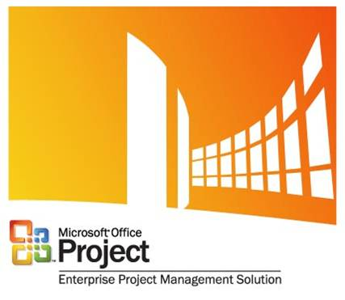

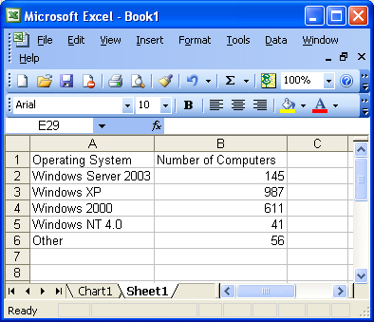

Microsoft Excel

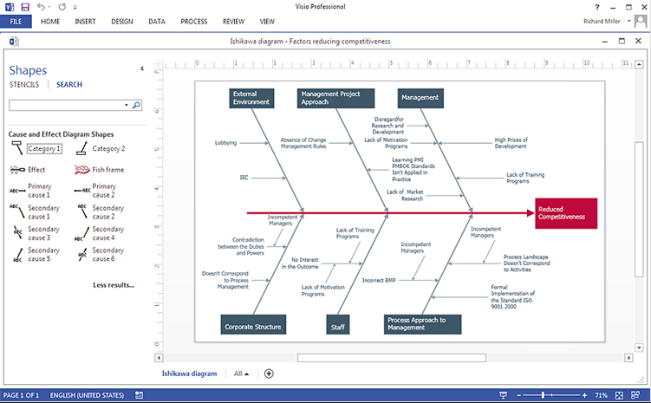

Visio Software

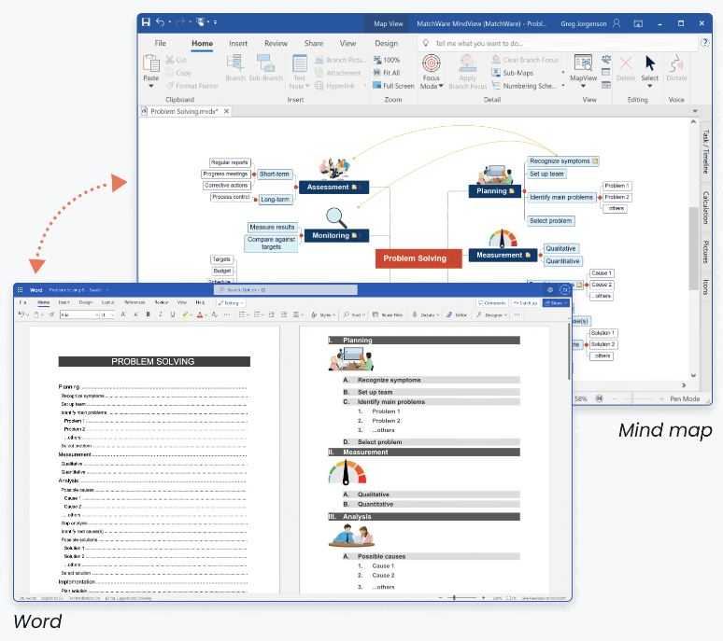

Mindview Software

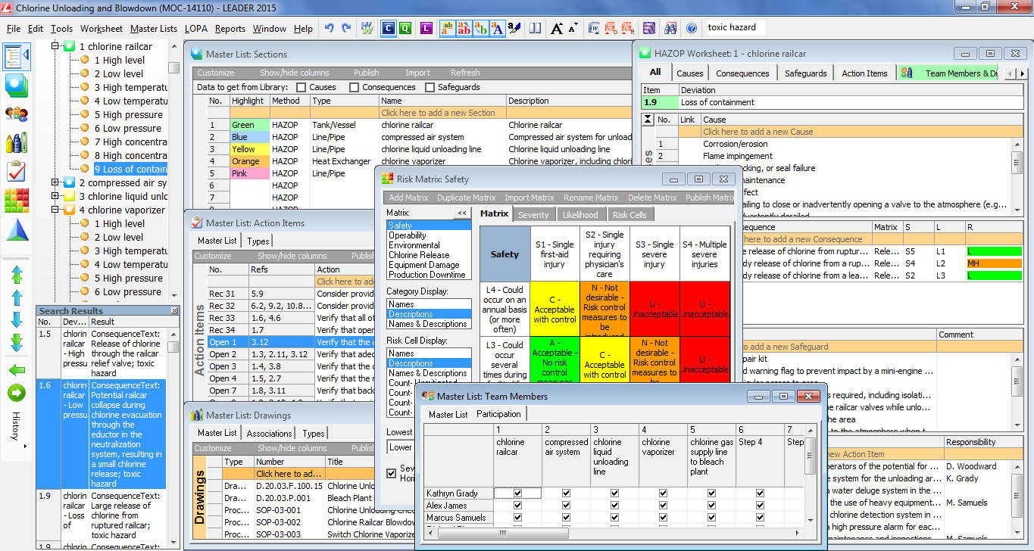
PHA/HAZOP Simulator

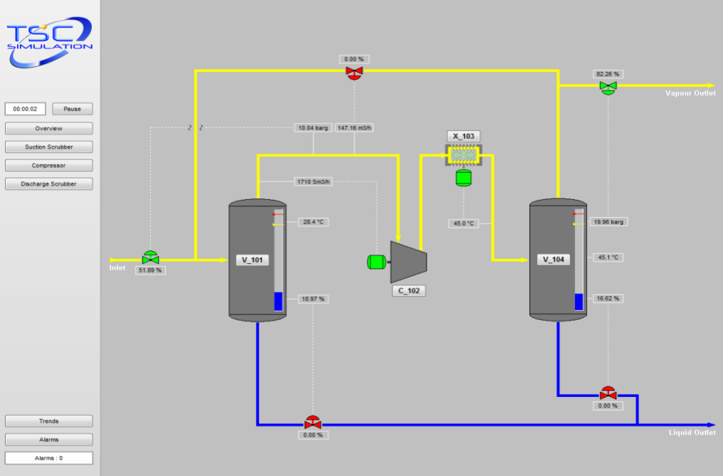

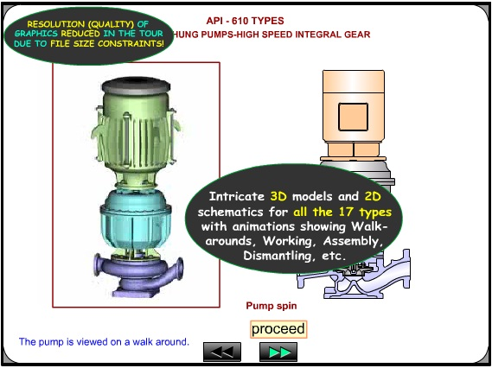

Centrifugal Pumps and
Troubleshooting Guide 3.0

SIM 3300 Centrifugal Compressor Simulator

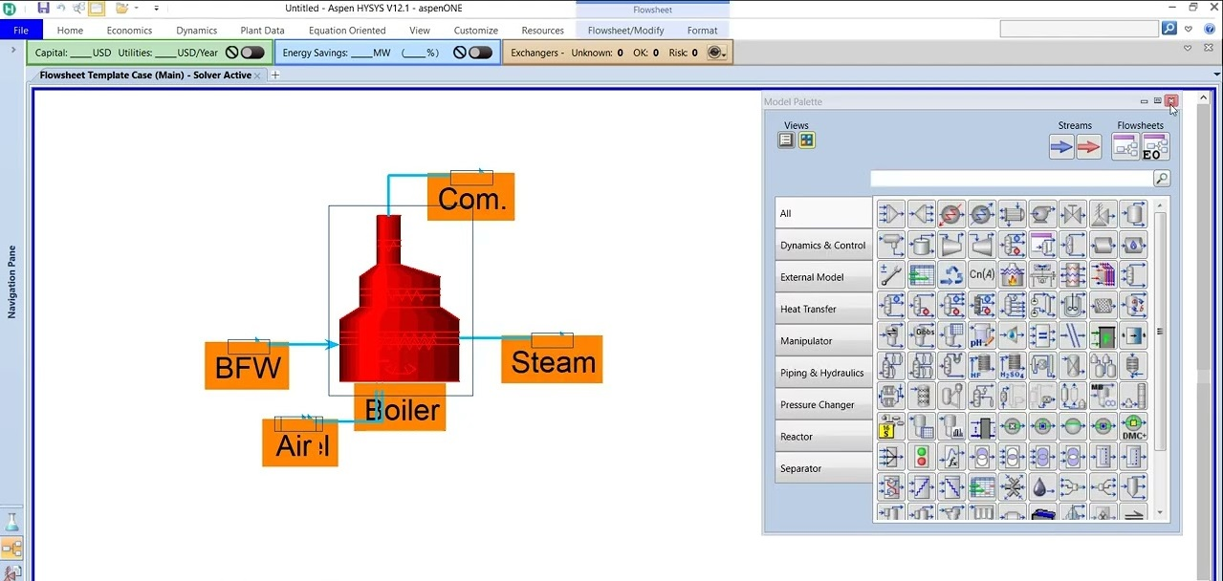

ASPEN HYSYS V12.1 Simulator

Course Coordinator
Mari Nakintu, Tel: +971 2 30 91 714, Email: mari1@haward.org

